

Destination- Kerala
No. Of Person: 2Adult No. of nights –5N 6Days
Hotel :3*

Package cost Per Person INR 45,000-/ Including Service Tax.

Inclusions

5Night stay at above mentioned hotel

Daily buffet breakfast

Munnar Local Sightseeing (Mattupetty Dam, Echo Point, Nursery Garden, Photo Point, Eravikulam National Park, and Tata Tea Museum (Closed on Mon)

Enroute Munnar Sightseeing (Visit Spice Plantations and Valara or Cheeyappara Falls)

Thekkady Local Sightseeing (Visit to Periyar Tiger Reserve, Periyar Lake Boat Safari (Tickets Excluded), and Kumili Village)

Enroute Cochin Sightseeing (Jewish Synagogue, St. Francis Church, Dutch Palace, Chinese Fishing Net, and Marine Drive)

All sightseeing on private basis

Airport hotel transfer on private basis

Exclusion:

- Any compulsory room supplement during the tour.
- Video and Camera permits at sights.
- Meals outside of the stated meal plan.
- Use of vehicle other than the specified itinerary.
- Expenses of personal nature.
- Any other services not specified above.
- Late check-out and Early check-in

Suggested day wise Itinerary

DAY 01: COCHIN TO MUNNAR via WATERFALLS (130KM 4 HRS DRIVE

Assistance provided by our representative from the moment you arrive at the Cochin railway station or airport. He will escort you to Munnar and on the way you can savour splendid views of tea plantations and small towns looking beautiful with the backdrop of picturesque lush surroundings. Besides this you can witness Cheyyappara waterfalls, Valara waterfalls view Point and Adimali, a wholesale place for cardamom are other attractions worth exploring. After reaching Munnar town you can check in your hotel, relax and enjoy an overnight stay.
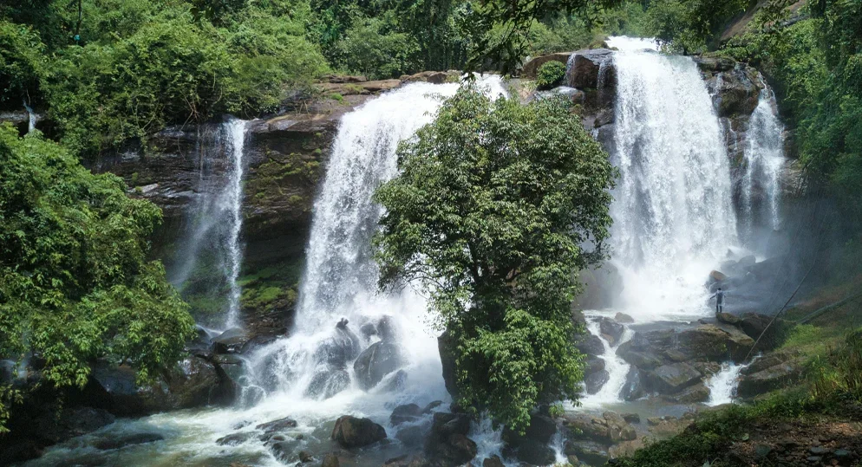

DAY 02: MUNNAR TOUR

In the morning after breakfast, Munnar begins with breakfast after which sightseeing is organized. The first destination is the fabulous Mattupatty Dam which proffers splendid views of gushing waters. You can enjoy an optional boat drive here. Echo point is well renowned for natural echo phenomenon the famous Shooting Point where film shootings are organized and Kundala Lake offering Shikara boating (Own Cost. Sightseeing continues a visit to Tea Museum Blossom Park and Pothamedu View Point. Following this, sightseeing ends and you can get back to your hotel and relax.

DAY 03: MUNNAR TO THEKKADY
In the morning after breakfast proceed to the thekkady check-in to the hotel or visit local places, overnight at the hotel.

Day04: THEKKADY (PERIYAR) tour
In the morning after breakfast visit many wonderful attractions like the Periyar Wildlife Sanctuary along the way. You can then reach Thekkady and check in to the hotel. After resting for a while, you can indulge in exciting optional activities like elephant safari, Kalaripayattu – a traditional martial art form, Kathakali show, jungle jeep safari (this is also online booking which you can do directly Ayurveda massage, garden visit and boating in Periyar (online booking own cost). You are then taken back to the hotel, overnight at the hotel.
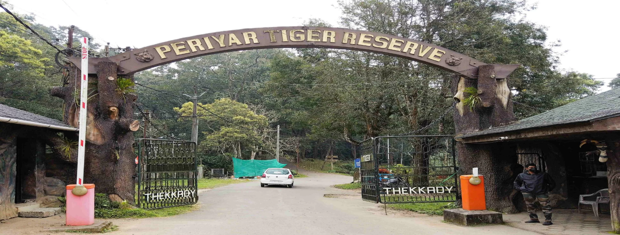

DAY 05: THEKKADY TO ALLEPPEY (3HRS -155KM)
In the morning after breakfast Enroute Cochin Sightseeing (Jewish Synagogue, St. Francis Church, Dutch Palace, Chinese Fishing Net, and Marine Drive), overnight at the hotel. 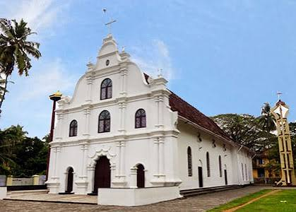

Day06: Have breakfast at hotel then ready for transfer to the airport according to your flight timing reach INDIA with sweet memories.

